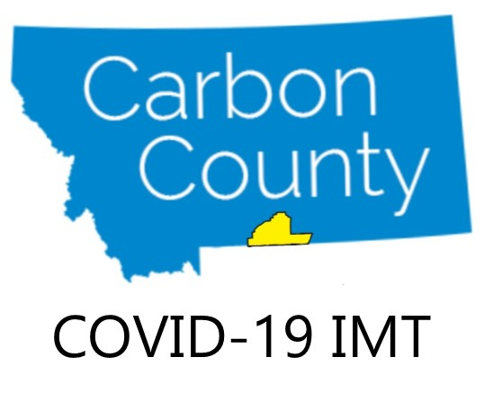

Contact: Carbon County COVID-19 Incident Management Team
Maggie Karas, Lead PIO, mkaras@beartoothbillingsclinic.org, 406-446-0616
Amy Hyfield, Deputy PIO, amy@redlodgefire.org 406-425-2257

News Release FOR IMMEDIATE RELEASE March 10, 2020

Carbon County Prepares for Possible COVID-19 Cases

Red Lodge, MT - As of March 10, there are currently no cases of Novel Coronavirus, COVID-19, infections in Montana. However, Carbon County is planning and preparing in the event infections do occur locally.

Last week the Carbon County Commissioners created the Carbon County COVID-19 Incident Management Team (IMT). The goals of the team are to reduce the risk of COVID-19 infection in first responders, healthcare providers, residents, and visitors in Carbon County, provide timely and accurate information and education, and make sure that services can continue within the county. Decision makers and key members of several Carbon County organizations are represented on the team including the Carbon County Commissioners, Carbon County Disaster and Emergency Services (DES), Beartooth Billings Clinic (BBC), Carbon County Public Health, Red Lodge Fire Rescue (RLFR) and the Carbon County Board of Health. Tom Kohley, Carbon County DES Coordinator and Jason Mahoney, Carbon County Public Health Emergency Preparedness Coordinator are leading the team as Incident Commanders.

The Carbon County COVID-19 IMT will work closely with all county medical facilities, Public Health, first responders, schools, and other stakeholders to coordinate planning, preparation, resources and information as we consider the possibility of COVID-19 entering the county.
First steps, which are already underway, include:
- provide reliable info and education for the public,
- provide specific info and training for healthcare providers, first responders, teachers and educators, and those working with especially vulnerable populations
- pursue adequate supplies of personal protective equipment.

Information on Carbon County’s response to COVID-19 can be found at CarbonAlert.org. Updates are available through Carbon Alert on Facebook and through newspapers and radio. An information call in number and additional social media outlets will be available soon.

If you think that you or a family member may be sick, please stay home and call your primary care provider to discuss the appropriate steps to take. Individuals with symptoms of concern are asked to contact their health care provider by PHONE and discuss the need for an medical evaluation. It is important to call your provider first so that precautions can be taken to reduce the risk to others in their setting in the event someone is diagnosed with COVID-19.

We encourage you to keep up to date on COVID-19 prevention measures, signs and symptoms and other general information on the Centers for Disease Control and Prevention’s webpage, www.cdc.gov/COVID19.

For more information on the Carbon County COVID-19 Incident Management Team, please email covid19imt@co.carbon.mt.us
###

